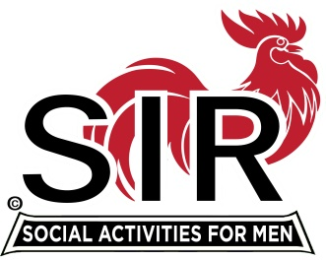
Las Trampas Branch 116
BEC Meeting Agenda
September 20, 2021, 8:30 AM via Zoom
[Zoom login at the bottom of the agenda]
The Mission of SIR is to enhance the lives of our members through fun activities, events and luncheons – while making friends for life.

8:30 am Call to order; Secretary confirm a quorum
8:35 Secretary –Paul Ramacciotti – Approval of August 16, 2021 BEC meeting minutes
8:40 Treasurer –/Alan Fitzgerald – Report
8:45 Standing Reports
- Membership – Phil Goff
- RAMP Department Head Reports:
- Recruitment
- Activity Coordinator
- Member relations
- Publicity
- Covid Compliance [Kevin Donahue]

9:00 Big SIR Report – Sam Beret
- September 20th monthly meeting agenda
- October 18 meeting – Zoom? Boundary Oak
- Warriors Zoom meeting

9:15 Little SIR Report - Fred Wachowicz
1. Speaker
2. Birthday Boys
3. Diversity Team Report

9:25 Old Business
Communications w/Boundary Oak – Alan F, Mike S

9:30 New Business
Christmas Party? Boundary Oak – Marty Katz

9:45 Adjourn; Next BEC Meeting, October 18, 2021
Zoom Link:

https://us02web.zoom.us/j/89269854543
Meeting ID: 892 6985 4543
Passcode: 826904

Dial-in: (669) 900-9128

